胡連精密股份有限公司
Hulane Precision Co. , Ltd.
文件編號  Docket number |  |  | HL-2190 | 文 件 名 稱  Name of document |  |  |  |  | 核 發 章  Authorization
制定單位  Unit of establishment |  |  | 人資處  Human Resources Department | 集團薪酬管理辦法  Measures for the administration of group compensation
制訂日期  Set date |  |  | JUl.05.2022
封 面
Cover
章 節 內 容
Chapter content

壹． 目 的
I. Objectives
貳． 範 圍
II. scope
參． 權 責 單 位
Ⅲ. Units of authority and responsibility
肆． 參 考 資 料
Ⅳ. Reference materials
伍． 定 義
V. Definitions
陸． 作 業 內 容
Ⅵ. Contents of assignments
柒． 附 件
Ⅶ. Annex

制 修 訂 記 錄 Make a record of amendments | 序 | 發 行 日 期  Release date |  |  | 版本、版次  Version |  | 頁 數  Number of pages | 章 節 內 容 概 述  Chapter Overview
制 修 訂 記 錄 Make a record of amendments | 1 | JUL.05.2022 |  |  | 1 | 0 | 4 | 新版  New Edition
制 修 訂 記 錄 Make a record of amendments | 2 | MAR.20.2024 |  |  | 1 | 1 | 4 | 陸.一.5.、陸.三.4.、陸.三.4.A.、陸.四.2.C.、陸.四.3.B.、陸.四.3.C.  Ⅵ. I. 5.、Ⅵ. III.4. 、Ⅵ. III.4. A. 、Ⅵ.Ⅳ2. C. 、Ⅵ.Ⅳ3. B.、Ⅵ.Ⅳ3. C.
制 修 訂 記 錄 Make a record of amendments | 3 | JUN.09.2025 |  |  | 1 | 2 | 4 | 陸、一、5.  Ⅵ. I. 5
制 修 訂 記 錄 Make a record of amendments | 4

制訂日期  Set date | JUl.05.2022 | 文件名稱  File name | 頁次  Page | 核發章  Chapter 1
文件編號  Docket number | HL-2190 | 集團薪酬管理辦法  Measures for the administration of group compensation | 1
版本、版次  Version | 1.2 |  | 1

目的Objective
胡連集團整體薪酬制度理念是肯定每位同仁負擔之職位職責、能力成長與績效表現，勉勵各位同仁一定要更加主動積極，勇於挑戰現況並承擔責任，持續自我成長並同步展現卓越績效，為自己在胡連集團的職涯發展創造更美好的未來。
The overall compensation philosophy of the HuLane Group is rooted in recognizing each employee’s job responsibilities, capability development, and performance achievements. It encourages all team members to take initiative, embrace challenges, and assume greater responsibility. By continuously growing and delivering outstanding results, employees can shape a brighter future for their career development within the HuLane Group..
固定薪酬制度強調連結外部標竿市場掌握薪資行情，並依據個人職位職責、績效結果與能力作為個人薪資給付及調整參考。
The fixed compensation system emphasizes alignment with external benchmark markets to stay informed of prevailing salary trends. Individual salary payments and adjustments are determined based on job responsibilities, performance outcomes, and capability levels.
變動薪酬制度強調引導同仁對於集團年度工作目標的達成及獎勵個人績效結果，透過差異化激勵卓越績效的展現。
The variable compensation system emphasizes guiding employees toward achieving the Group’s annual business objectives and rewarding individual performance
outcomes. Through differentiated incentives, it encourages the demonstration of exceptional results.

範圍Scope

本辦法適用於集團內各廠區(事業)單位。
These measures are applicable to each factory area (institution) within the group.

權責單位Authority and responsibility units

主辦單位為人資單位、協辦單位為各單位。
The organizer is the human resources unit, and the co-organizer is each unit.

參考資料References

HL-2188集團績效管理與發展辦法。
HL-2188 Group Performance Management Development Approach.

定義Definition：

薪酬管理制度是整體薪酬的概念，更能反映職責與市場行情、激勵能力提升與肯定績效貢獻，促以實現中長期組織發展策略、年度工作目標並達到人才激勵、吸引與留置。:

Compensation management system is the concept of overall compensation, more to reflect the responsibilities and market conditions, incentive ability to enhance and affirm the contribution of performance, promote the achievement of mid-and long-term organizational development strategy, annual work goals and achieve talent incentive, attract and retain.

作業內容Assignment

集團薪酬策略Group compensation strategy

整體薪酬反映職位職責、績效及能力，並連結外部薪資標竿市場。
The compensation management system embodies the concept of total rewards, offering a more comprehensive reflection of job responsibilities and market trends. It serves to motivate capability development and recognize performance contributions, thereby supporting the realization of the organization’s medium- to long-term strategic goals and annual objectives. Ultimately, it enhances talent motivation, attraction, and retention.

主管應落實薪酬溝通，協助同仁了解薪酬與職責及績效間的關連性，以鼓勵承擔更多職責並持續成長。
Managers shall implement effective compensation communication, helping employees understand the link between their pay, responsibilities, and performance. This encourages them to take on greater responsibilities and pursue continuous growth.

擴大績效卓越與績效一般員工的薪酬與發展的差異化，以激勵與留置優秀人才。
Enhance differentiation in compensation and development opportunities between high performers and average performers to motivate and retain top talent.

考量營運、人才資產策略及人才相互競爭交流者，以各地相近行業的領先企業作為整體薪酬標竿對象。
In consideration of business operations, talent asset strategies, and cross-talent competition and exchange, leading companies in similar industries across various regions are used as benchmarks for overall compensation.

為強化公司治理及推動永續發展，高階主管薪資報酬在營運成果與ESG相關績效評估連結項目為集團營收目標達成率、集團ROE達成率、事業(廠區)年度目標與計畫成果、事業(廠區)年度綜合月績效成果、人才培育與發展成果、集團永續發展成果。

To strengthen corporate governance and promote sustainable development, executive compensation is linked to both operational results and ESG-related performance indicators. These include: Group revenue target achievement rate, Group ROE achievement rate, Annual goals and project outcomes of each business unit (or site), Monthly comprehensive performance results of each business unit (or site), Talent development and cultivation outcomes, Group sustainability achievements.

制訂日期  Set date | JUl.05.2022 | 文件名稱  File name | 頁次  Page | 核發章  Chapter 1
文件編號  Docket number | HL-2190 | 集團薪酬管理辦法  Measures for the administration of group compensation | 2
版本、版次  Version | 1.1 |  | 2

集團薪酬架構Group compensation structure

固定薪酬：依據以職責為基礎的職涯層級架構，依個人市場競爭力與績效表現，建立差異化的價值分配。
Fixed Compensation: Based on a responsibility-driven career level framework, differentiated value distribution is established according to individual market competitiveness and performance outcomes.

變動薪酬：反映公司年度策略目標的達成結果，用以獎勵單位及個人整年度績效成果。
Variable Compensation: Reflects the achievement of the company’s annual strategic objectives and serves to reward both unit-level and individual performance outcomes over the full year.

學習與成長：《職涯發展藍圖》規劃與溝通員工中長期職涯發展機制、《系統化訓練機制》提供專業與管理能力的訓練體系及經驗傳承機制等、《內部輪調機制》規劃並加速多元技能人才養成。
Learning and Development:

- The Career Development Blueprint outlines and communicates mechanisms for employees’ medium- to long-term career planning.

- The Systematic Training Framework provides structured programs for professional and managerial skill development, along with mechanisms for knowledge transfer.

- The Internal Job Rotation Mechanism is designed to accelerate the cultivation of multi-skilled talent through planned cross-functional experiences

非金錢性獎勵：肯定與表揚績效優異的團隊或同仁、給予即時口頭表揚或書面肯定等。
Non-Monetary Rewards: Recognize and commend high-performing teams or individuals through timely verbal praise or written acknowledgments.

員工福利：保障員工生存及安全感需求，實用性與人性化的輔助。
Employee Benefits: Designed to safeguard employees’ basic living and security needs, the benefits system emphasizes practicality and human-centered support.

三、 固定薪酬 Fixed Compensation

固定薪酬之設計重點 Key Design Principles of Fixed Compensation

連結專業與人才市場行情，依地制宜建立多元薪資表，高階主管以下區分為營運專業、研發技術、業務銷售、生產作業等薪資表。
Linking to Professional and Talent Market Trends: Tailor diverse salary structures based on regional conditions and market benchmarks. Below the executive level, salary tables are differentiated by functional categories such as operations, R&D and technical roles, sales and business development, and production-related positions.

部組織層級以上主管具薪酬管理及建議權，月固定薪給付根據同仁的職位職責、績效與能力展現。
Managers at the departmental organizational level and above hold the authority to manage and recommend compensation. Monthly fixed salaries are determined based on employees’ job responsibilities, performance, and demonstrated capabilities.

月固定薪作為薪資調整及績效獎金發放的基礎。
Monthly fixed salary serves as the basis for salary adjustments and performance bonus distribution.

月固定薪調整主要考量公司整體績效及預算、薪資競爭力及人才評等結果。
Adjustments to monthly fixed salaries are primarily based on the company’s overall performance and budget, market salary competitiveness, and talent evaluation results.

固定薪酬之設計流程

Design Process for Fixed Compensation

- 固定薪酬之設計流程Design Process for Fixed Compensation
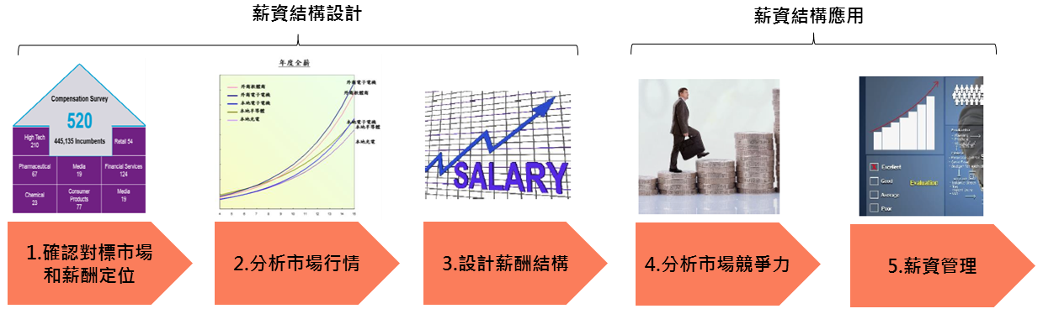
步驟1：確認對標市場和薪酬定位Confirm the benchmark market and compensation positioning ；
步驟2：分析市場行情Conduct market compensation analysis；
步驟3：設計薪酬結構Design compensation structure
步驟4：分析市場競爭力Analyze Market Competitiveness
步驟5：薪資管理Compensation management
- 每年將參考各地市場預期調薪率及考量公司成長性，於第二季度進行薪資檢視活動，以確保達成人才激勵、吸引與留置。
Each year, the company conducts a salary review in the second quarter, referencing projected market adjustment rates across regions and considering overall business growth, to ensure effective talent motivation, attraction, and retention.

制訂日期  Set date | JUl.05.2022 | 文件名稱  File name | 頁次  Page | 核發章  Chapter 1
文件編號  Docket number | HL-2190 | 集團薪酬管理辦法  Measures for the administration of group compensation | 3
版本、版次  Version | 1.1 |  | 3
- 薪資檢視環節：Salary review:

薪檢矩陣採用雙維度(薪資競爭力、人才評等)矩陣，以確保薪檢最適分配兼顧市場連結與激勵優秀人才。
The salary review matrix adopts a dual-dimensional approach—market competitiveness and talent evaluation—to ensure optimal salary distribution that balances external market alignment and internal motivation for high-performing talent.

年度薪資檢視簽核流程，依<HL-6002重要事項核決權限一覽表>執行。
The annual salary review and approval process is carried out in accordance with the< HL-6002 List of Delegation of Authority on Important Matters >

員工溝通：主管應落實薪酬溝通，引導員工正向思考薪資檢視的結果，並強調職位職責、績效及能力與整體薪酬的關聯性，鼓勵員工承擔更多職責並展現更好的績效。
Employee Communication: Managers should actively engage in compensation-related discussions with employees, guiding them to view salary review outcomes positively. It is important to emphasize the connection between job responsibilities, performance, and capabilities with overall compensation, thereby encouraging employees to take on greater responsibilities and deliver stronger performance.
四、變動薪酬Variable compensation
1. 變動薪酬之設計重點
1. Key points in the design of variable compensation
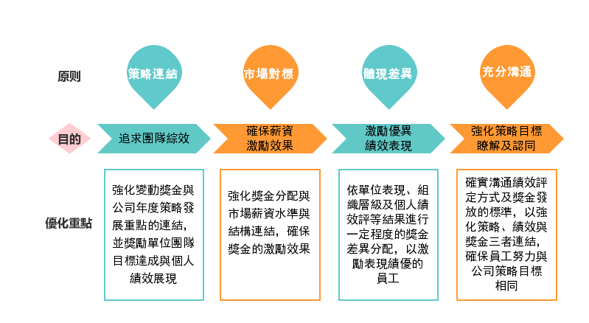
2. 變動薪酬之設計流程 The design process of variable compensation
- 決定變動薪酬總額：依集團年度策略性指標達成，決定變動獎金發放水準。
Determining the Total Variable Compensation: The level of variable bonus distribution is determined based on the achievement of the group’s annual strategic
performance indicators.
- 決定績效單位獎金發放水準：依各績效單位年度關鍵績效指標達成結果計算目標達成率，以決定各單位績效獎金發放水準。
Determining Performance Unit Bonus Distribution Levels: The bonus distribution level for each performance unit is determined based on the achievement rate of
its annual key performance indicators (KPIs).
- 決定個人變動獎金發放水準：依個人職等及人才評等結果，分配個人變動獎金。
Determining Individual Variable Bonus Distribution Levels: Individual variable bonuses are allocated based on the employee’s job grade and talent evaluation
results.

3. 變動薪酬之發放原則The principle of variable compensation
- 變動獎金發放時，已離職者不計入計算。
Employees who have resigned are excluded from variable bonus calculations at the time of distribution
- 變動獎金發放時，留職停薪者計入計算，獎金保留至復職日滿三個月後發放。
Employees on unpaid leave are included in the variable bonus calculation, but their bonus will be withheld and released only after three full months of reinstatement.
- 發放周期：依集團人資處發放通知。
Distribution Schedule: Variable bonuses are issued according to the notification schedule provided by the Group Human Resources Division.

制訂日期  Set date | JUl.05.2022 | 文件名稱  File name | 頁次  Page | 核發章  Chapter 1
文件編號  Docket number | HL-2190 | 集團薪酬管理辦法  Measures for the administration of group compensation | 4
版本、版次  Version | 1.1 |  | 4
五、 保密原則 Confidentiality
集團薪酬制度嚴格執行「密等密薪制」，人資及員工本人不得以任何方式討論與洩露相關資訊，具體保密規範行為如下:
The group’s compensation system strictly enforces a “classified and confidential pay policy,” under which HR personnel and employees themselves are prohibited from discussing or disclosing any related information through any means. Specific confidentiality guidelines include the following:
- 主管不得有以下行為 Managers must refrain from the following behaviors:
  - 洩露或與他人討論自己或所轄同仁的職等與薪資資訊(薪資水準、薪資競爭力)。
Disclosing or discussing one's own or subordinates’ job grades and compensation information (including salary levels and market competitiveness) with others.
  - 與他人討論單位整體月薪及變動獎金預算與實際發放數。
Discussing the unit’s overall monthly salary, variable bonus budget, or actual payout figures with others.
- 同仁不得有以下行為 - Employees must refrain from the following behaviors:
  - 詢問他人的職等與薪資資訊。
Asking others about their job grades or compensation details.
  - 探詢他人的薪資調整幅度與調整金額。
Inquiring about others’ salary adjustment rates or adjustment amounts.
  - 打聽他人變動獎金領取的月份數。
Probing into the number of months others received variable bonuses.

柒、 附件：無。
Attachment: None.

